* **Default**

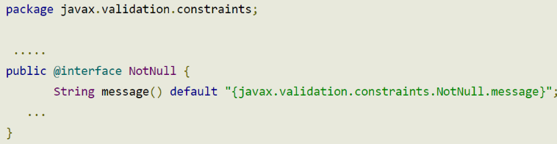

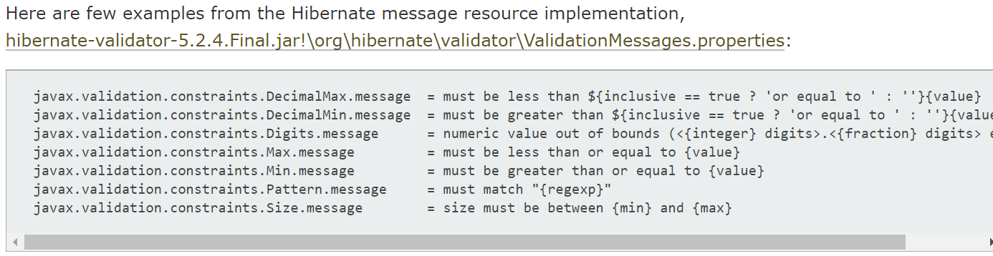

*Default*

<https://www.logicbig.com/tutorials/java-ee-tutorial/bean-validation/validation-messages.html>

* **Có 2 cách để custom lại message**
  + **Message attribute**

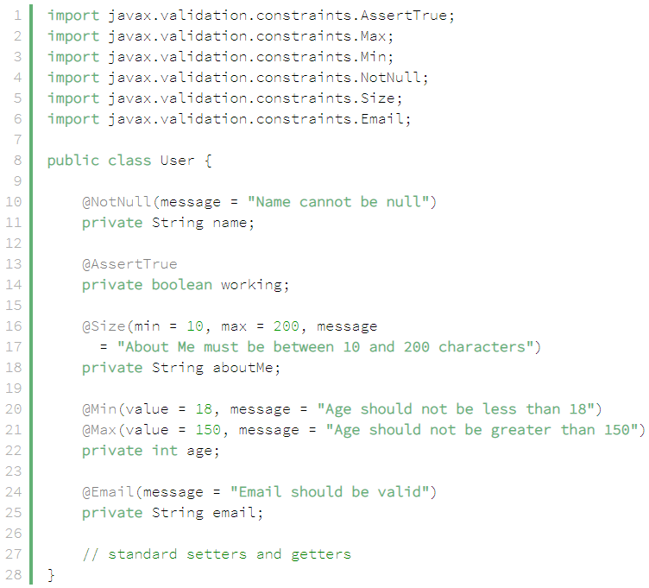

*Config attribute message ở @Annotation*

* + **Property file**

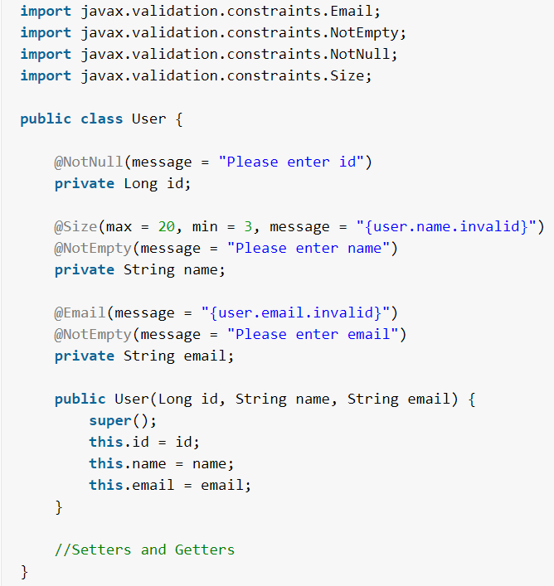

*Object Validation*

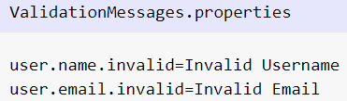

*ValidationMessages.properties file ở trong resource*

* + **Config message cho nhiều ngôn ngữ khác nhau**

Default: message có thể được dịch ra hơn 10 ngôn ngữ khác nhau

<https://www.logicbig.com/tutorials/java-ee-tutorial/bean-validation/validation-messages.html>

* **Reference**

<https://howtodoinjava.com/hibernate/hibernate-validator-java-bean-validation/>

<https://docs.jboss.org/hibernate/stable/validator/reference/en-US/html_single/#section-resource-bundle-locator>